Decorator Pattern Example

We're going to create a *Shape* interface and concrete classes implementing the *Shape* interface. We then create a abstract decorator class *ShapeDecorator* implementing the *Shape* interface and having*Shape* object as its instance variable.

*RedShapeDecorator* is concrete class implementing *ShapeDecorator*.

*DecoratorPatternDemo*, our demo class will use *RedShapeDecorator* to decorate *Shape* objects.

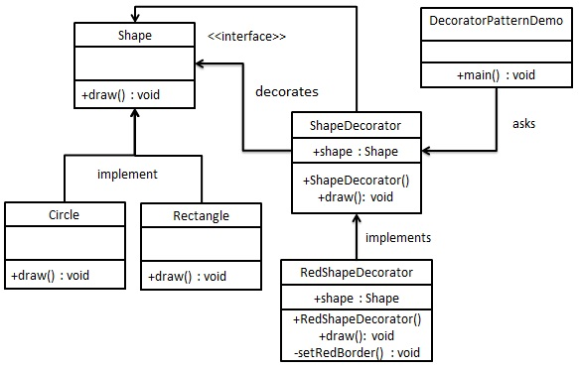

Step 1

Create an interface.

*Shape.java*

public interface Shape {

void draw();

}

Step 2

Create concrete classes implementing the same interface.

*Rectangle.java*

public class Rectangle implements Shape {

@Override

public void draw() {

System.out.println("Shape: Rectangle");

}

}

*Circle.java*

public class Circle implements Shape {

@Override

public void draw() {

System.out.println("Shape: Circle");

}

}

Step 3

Create abstract decorator class implementing the *Shape* interface.

*ShapeDecorator.java*

public abstract class ShapeDecorator implements Shape {

protected Shape decoratedShape;

public ShapeDecorator(Shape decoratedShape){

this.decoratedShape = decoratedShape;

}

public void draw(){

decoratedShape.draw();

}

}

Step 4

Create concrete decorator class extending the *ShapeDecorator* class.

*RedShapeDecorator.java*

public class RedShapeDecorator extends ShapeDecorator {

public RedShapeDecorator(Shape decoratedShape) {

super(decoratedShape);

}

@Override

public void draw() {

decoratedShape.draw();

setRedBorder(decoratedShape);

}

private void setRedBorder(Shape decoratedShape){

System.out.println("Border Color: Red");

}

}

Step 5

Use the *RedShapeDecorator* to decorate *Shape* objects.

*DecoratorPatternDemo.java*

public class DecoratorPatternDemo {

public static void main(String[] args) {

Shape circle = new Circle();

Shape redCircle = new RedShapeDecorator(new Circle());

Shape redRectangle = new RedShapeDecorator(new Rectangle());

System.out.println("Circle with normal border");

circle.draw();

System.out.println("\nCircle of red border");

redCircle.draw();

System.out.println("\nRectangle of red border");

redRectangle.draw();

}

}

Step 6

Verify the output.

Circle with normal border

Shape: Circle

Circle of red border

Shape: Circle

Border Color: Red

Rectangle of red border

Shape: Rectangle

Border Color: Red